FORM 9
THE PATENT ACT 1970
(39 OF 1970) &
The Patents Rules, 2003
REQUEST FOR PUBLICATION
[See section 11A (2); rule 24A]
- Name, address, and nationality of the applicants | We  1) Name: Mrs. Gavini Venkata Leela Kumari  Nationality: India  Address: Assistant Professor,  Department of CSE (Artificial Intelligence and Machine Learning),  Bapatla Engineering College, Bapatla 522102,  Andhra Pradesh, India  2) Name: Mr. Palaparthi Venkata Naga Srinivas  Nationality: India  Address: Assistant Professor,  Department of CSE (Artificial Intelligence and Machine Learning),  Bapatla Engineering College, Bapatla 522102,  Andhra Pradesh, India  3) Name: Gaddam Venu  Nationality: India  Address:  Department of CSE (Artificial Intelligence and Machine Learning),  Bapatla Engineering College, Bapatla 522102,  Andhra Pradesh, India  4) Name: Jeevan Devandla  Nationality: India  Address  Department of CSE (Artificial Intelligence and Machine Learning),  Bapatla Engineering College, Bapatla 522102,  Andhra Pradesh, India  5) Name: Gulivindala Sri Lakshmi Sarojini  Nationality: India  Address  Department of CSE (Artificial Intelligence and Machine Learning),  Bapatla Engineering College, Bapatla 522102,  Andhra Pradesh, India  6) Name: Doppalapudi Sri Sai Teja  Nationality: India  Address  Department of CSE (Artificial Intelligence and Machine Learning),  Bapatla Engineering College, Bapatla 522102,  Andhra Pradesh, India  7) Name: Mudraboina Durgarao  Nationality: India  Address  Department of CSE (Artificial Intelligence and Machine Learning),  Bapatla Engineering College, Bapatla 522102,  Andhra Pradesh, India  8) Name: Bapatla Engineering College  Nationality: India  Address  Department of CSE (Artificial Intelligence and Machine Learning),  Bapatla Engineering College, Bapatla 522102,  Andhra Pradesh, India.
- To be signed by the applicant or his authorized registered patent agent | hereby request for early publication of my/our application for patent no TEMP/E-1/49686/2026-CHE Dated 09-04-2026 under section 11A(2) of the act  Dated this 9th day of April 2026
- Name of the natural person who has signed | Signature:  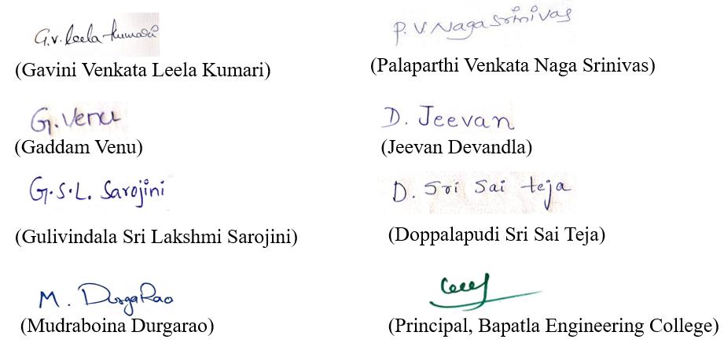  To,  The controller of patent  Patent office at, Chennai.

